**ISOTHERMAL TITRATION CALORIMETRY (VP-ITC)**

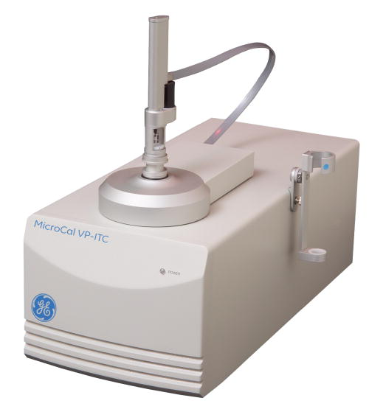

**Direct and label-free measurement of binding affinity and thermodynamics are obtained with MicroCal VP-ITC. Heat released or absorbed during biochemical binding events is measured directly, giving information relative binding affinity (Kd), stoichiometry (n), enthalpy (ΔH), and entropy (ΔS). This information provides valuable insights into the mechanism of binding.**

|  |  |
| --- | --- |
| Instrument Specifications | |
| Model or Type | **VP-ITC** |
| Performance Specifications | |
| Short Term Noise (RMS Average) | 0.5 nanocal/sec (2 nanowatts)A |
| Control Peak Repeatability | Mean ≤ 1.5μCal., s.d. ≤150 nCal B |
| Minimum Response Time (high gain) | 20 seconds |
| Operating Temperature Range | 2° to 80° C |
|  |  |
| Physical Specifications | |
| Cell Material | Hastelloy® Alloy C-276 |

**Accessories**

* Ultrasensitive VP-ITC Microcalorimetry Cell.
* VP control unit
* Themo Vac Temperature controlled sample preparation and cleaning device.
* Three injection syringe, syringe holder, pipette stand
* Accessories box with: Filling and empting syringe and assemblies and more.