FT-IR Spectrophotometer (Brucker Vertex-70)

The Bruker Vertex 70 is used to obtain an infrared spectrum of absorption, emission, photoconductivity or Raman scattering of a solid, liquid or gas.

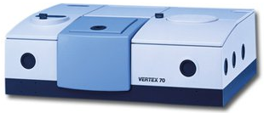
Specifications:

* Spectral range: 4000 to 350 cm⁻¹

* Beam splitter option: KBr (Broadband): 10000 to 380 cm⁻¹

* Source: Internal ceramic source for mid, air cooled.

* Detector: DigiTect detector system.

* Spectral resolution: Better than 0.4 cm⁻¹

* wavenumber accuracy: Better than 0.01 cm⁻¹
* Photometric accuracy: Better than 0.1%T
* Aperture ratio: f/205, nominal bean diameter 40mm (1.37”)
* Rapid scan: 15 spectra/ sec @ 1 cm⁻¹
* Sample compartment: 2505(W) * 27(D) *16(H) cm

Accessories:

- High resolution scanner (0.16 ) cm⁻¹

- Photovoltaic MCT detector

- Double column air driver

- Built-in casing for air deriver S112

- Bio-ATRI cell, horizontal ATR unit

- Bio-ATRcell ll for infrared proteomics

- AquaSpec cell

