SCANNING ELECTRON MICROSCOPE (Model: EVO 40XVP CARL ZEISS)

The EVO®40 microscope is ideal for pharmaceutical and biotech research offering superb imaging of small specimens. The chamber design provides excellent access to the specimen for cryo and other specialist techniques. Its key features are: VPSE detector for secondary imaging in XVP® and BeamSleeve™ accurate analysis of non conducting samples
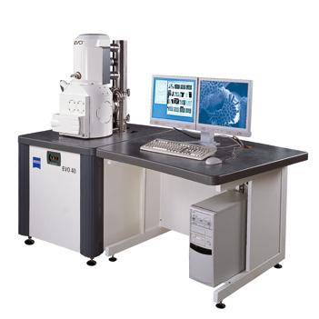
Specifications

Resolution
3.0 nm @ 30 kV (SE and W)
4.5 nm @ 30 kV (BSD - XVP® mode)
Acceleration Voltage
0.2 to 30 kV
Magnification
7 to 1,000,000x
Field of View
6 mm at the Analytical Working Distance (AWD)
X-ray Analysis
8.5 mm AWD and 35° take-off angle
OptiBeam® Modes
Resolution, Depth, Analysis, Large Field
XVP® Pressure Range/EP Pressure Range
5 - 750Pa with air, or optionally water vapour
5 - 3000Pa with air
5 - 2000Pa with water vapour
Available Detectors
SE in HV - Everhart-Thornley
SE in XVP® - VPSE
SE in EP - EPSE
BSD in all modes - quadrant semiconductor diode

Chamber
310 mm (Ø) x 220 mm (h)
5-Axes Motorised Specimen Stage
X = 80 mm
Y = 80 mm
Z = 35 mm
T = 0° -90°
R = 360° (continuous)
Stage control by mouse or optional joystick and controlpanel
Future Assured upgrade paths
HV -> XVP® -> EP
Image Processing
Resolution: Up to 3072 x 2304 pixel
Signal acquisition by integrating and averaging
Image Display
Single flicker-free XVGA monitor with SEM image displayed at 1024 x 768 pixel

ACCESSORIES
- Basic unit EVO 40XVP, Tungsten Emission system.
- Operating system windows XP pro.
- Dual joystick stage controller
- EVO 40 VPSE G3 detector.
- EVO lens mounted four quadrant silicon diode

