Transmission Electron Microscope (JEM – 2100CR)

The JEM-2100 electron microscope provides solutions for a wide range of problems in the fields of materials, nano electronics, and biological sciences. 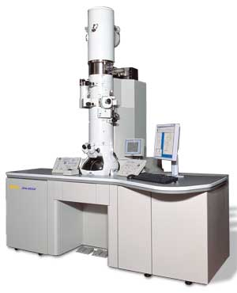
Specifications:
- Resolution :
  - Point Resolution : 0.3 nm or better
  - Lattice Resolution : 0.14 nm or better
- EHT : 200 KV selectable at 80-100-120-160-200KV
- Filament :
  - Pre-centred single crystal Lab 6 High stability.
  - Automatic airlock and gun lift capability.
- Specimen Stage:
  - TYPE: Computer controlled Eccentric side entry goniometer at least 2 axes motorise (x & y) fine control for Z movement, motor drive and ± 70° tilt.

  - SPECIMEN MOVEMENTS :
    - X = 2 mm , motorised
    - Y = 2 mm , motorised
  - SPECIMEN DRIFT : <1nm/min at 0°C, <2.5 nm/min at 70°C, less than 2µ during 70°C.
- Imaging System :
  - Magnification Ranges : Total range 50x – 1,000,000x
  - Plate Camera : 6.5 cm x 9 cm plate size
  - 2K x 2K Post Column digital Camera
Features:
  - Single Crystal Lab 6 K type filament
  - Sheet Film Holder
  - Film Dessicator
  - RP-DP-SIP pumping
  - CM lens Unit
  - Motorized OL aperture
  - Gatan digital camera and software

