TGA/DSC (METTLER TOLEDO; Model TGA/DSC-l)

Thermogravimetric Analysis is a technique in which the mass of a substance is monitored as a function of temperature or time as the sample specimen is subjected to a controlled temperature program in a controlled atmosphere. TGA measures a sample’s weight as it is heated or cooled in a furnace. A TGA consists of a sample pan that is supported by a precision balance. That pan resides in a furnace and is heated or cooled during the experiment. The mass of the sample is monitored during the experiment. A sample purge gas controls the sample environment. This gas may be inert or a reactive gas that flows over the sample and exits through an exhaust.
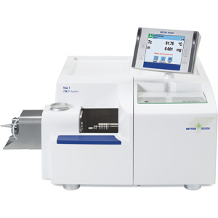

Specifications

Balance Design | Parallel guided Micro Balance, independent of sample positioning. Thermo stated balance housing with auto calibration facility with built-in- std ring weights.
Balance Capacity | ~ 200 mg with 1 µgm resolution without range switching.
Baseline/blank reproducibility | < +/- 10ug for the full temperature range.
Thermostat device for Balance and Furnace | Thermostat device for balance to minimise drift.
Furnace design | Horizontal Design to give stable weight signal.
Temperature Range | RT to 1100°C with accuracy of +/- 0.25°C,  Sample should follow the program temperature up to 1100°C without any thermal lag. Temp. calibration with pure melting point standards.
Heating / cooling rate | 250 K/Min. / -20K/min
Calibration | The system have facility to calibrate with certified pure metal standard for the full temperature range up to 1100 ºC.  System should not require recalibration when changing crucible, gases and heating rates. This is a must.
DTA –DSC Capability | The system is able to perform Simultaneous DTA/DSC measurement for measurement of enthalpy etc. with unique user replaceable sensor with optional auto samplers (>24 positions)
Data acquition system /Software | State of art computer system with minimum i5 or better CPU, 360 GB or more HDD, 19” LED monitor and suitable LASER printer. Windows operative system software with multitasking, possibilities optimised for storage and retrieval of TA data,  The software should have capability e,g single step, multi-step or multi-limit, auto-limit; choice of different baselines for interpretation (line, tangential, horizontal, spline, Integral tangential, polygon line etc for correct evaluation/integration of peaks).
Crucible | Al2O3- 70 µl, Pt- 70 µl. etc,

